ABC Organizer
Topic: Winter Camping
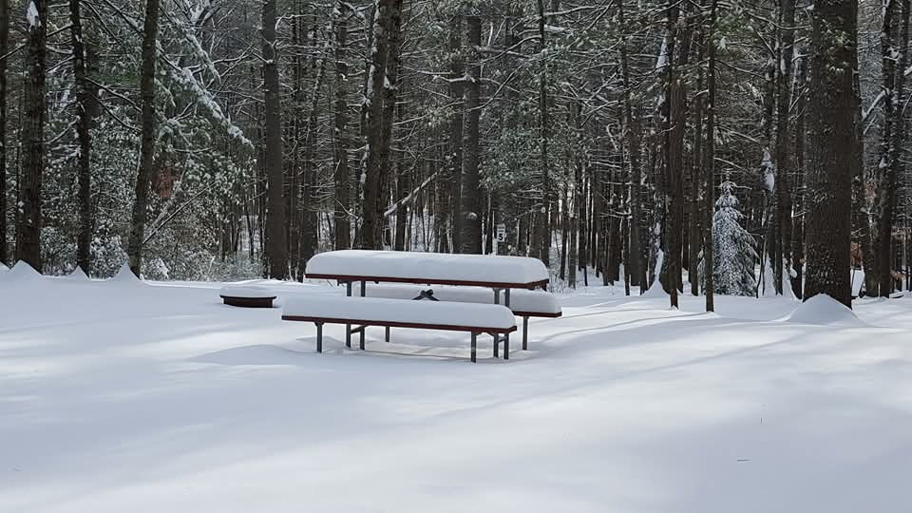

A _________________________ N___________________________
B _________________________ O___________________________
C _________________________ P ___________________________
D _________________________ Q ___________________________
E _________________________ R ___________________________
F _________________________ S____________________________
G _________________________ T ____________________________
H _________________________ U ____________________________
I __________________________ V ____________________________
J __________________________ W ____________________________
K__________________________ X_____________________________
L __________________________ Y _____________________________
M __________________________ Z _____________________________

