Prior Knowledge Inventory

Topic: Winter Activities
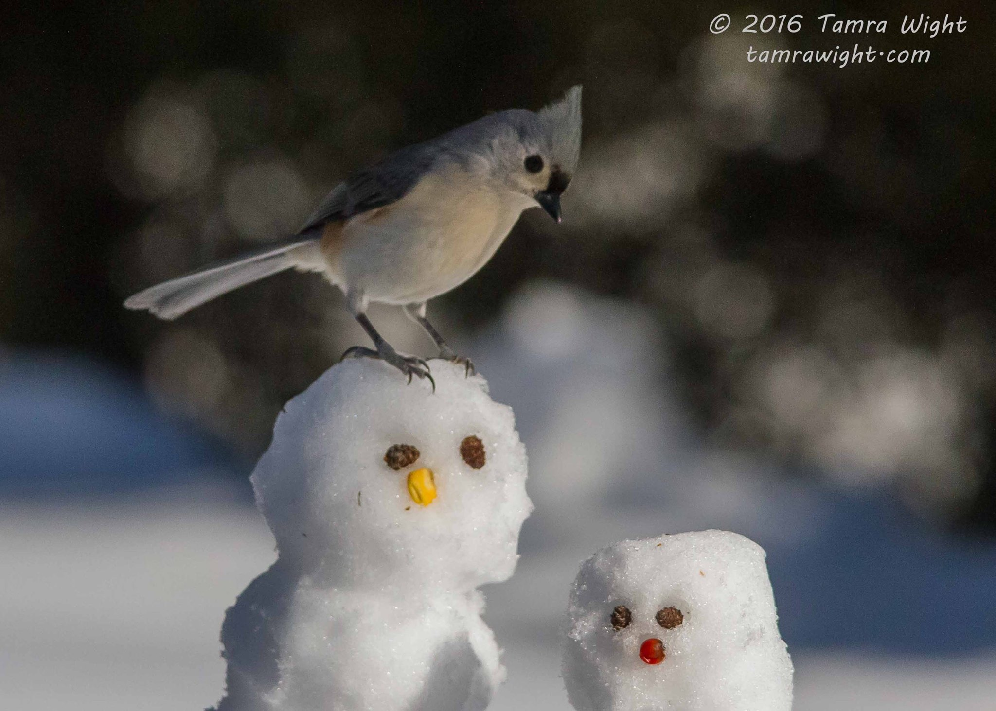

Some words I know that are related to the topic:
1.
2.
3.
4.
5.
Three facts I already know about this topic:
1.
2.
3.

Two experiences that I have had related to this topic are:
1.

2.

Given this topic, I would like to know more about:
1.

2.

